​**NO POLICE REPORTS FILED FOR ANY WRONGDOING ON MY PART, OR BY THE NYPD FOR MY ONLY FIRE EGRESS WITH NO FIRE SYSTEM IN PLACE EITHER. OTHERWISE THE FIRE ALARM WOULD BE GOING OFF “CONSTANTLY” - WHICH IS HARASSMENT**

ALL DAMAGES PAID ENTERED BY COUNSEL FOR PLAINTIFF; NO BOX CHECKED ON THE LEASE OR RIDER FOR YOU TO BILL ME.

1/8" MIRROR. *STATE FARM MATERIAL-8-9-10-GRAVYTRAIN.PDF*

CAMERAS POINTED AT MY LAPTOP

     8, 9, 10 at **4AM**

**[15TH of November, 2021]**

**$10,501.21 FIRM, I DON’T NEED A CERTIFIED CHECK**

**FRONT DESK**  
215 West 94Th Street, New York, 10025

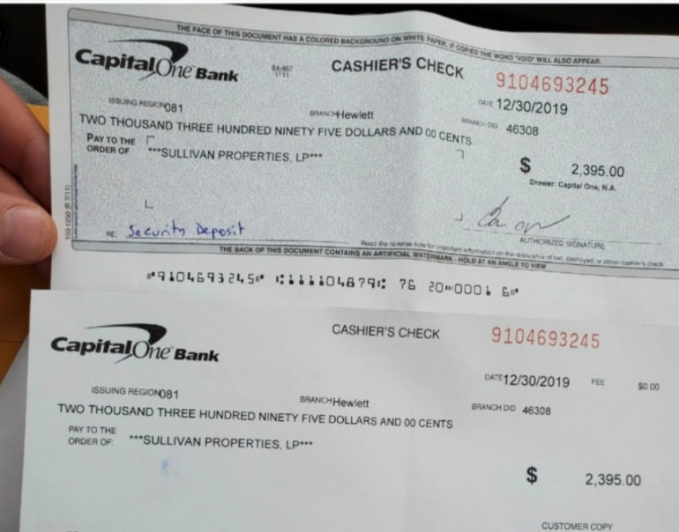

I have some other questions…

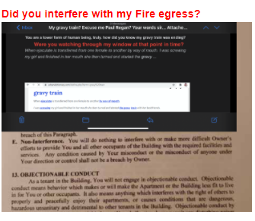 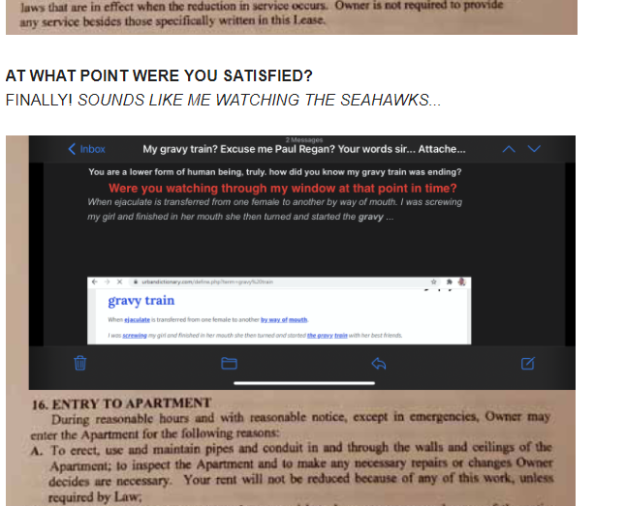

*Do you believe I am the reason why COVID has caused a mass exodus of your Property, at this point?*

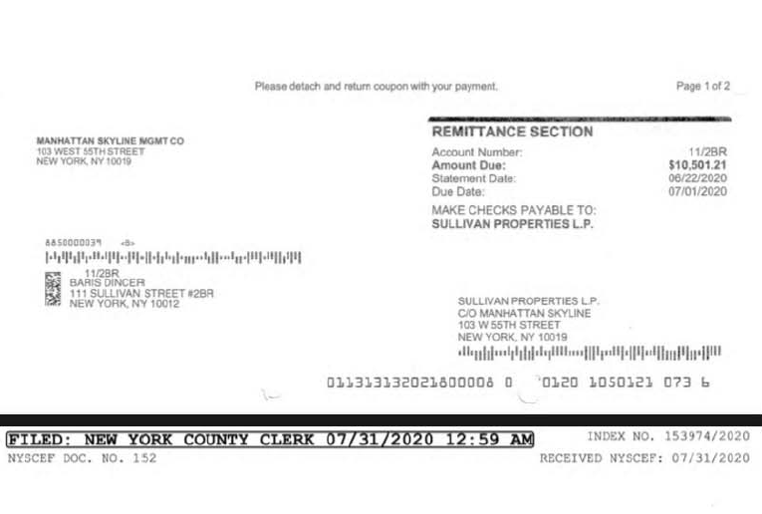

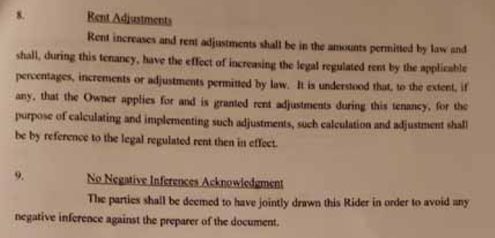

**Are you sure about that?**   
